**Milestone 4**

Erick Grant

CSET, Grand Canyon University

CST-239: Programming in Java II

Professor Jackson

March 12 2023

Youtube Link: https://youtu.be/dXsF36P-yNo

GitHub: <https://github.com/esyew/SoftwareDrop> (needs authentication)

Notion: <https://esyew.notion.site/Milestone-4-File-I-O-Integration-354996782039449ca3d5a7cc99b8bb8f>

Flowchart (on Next Page)

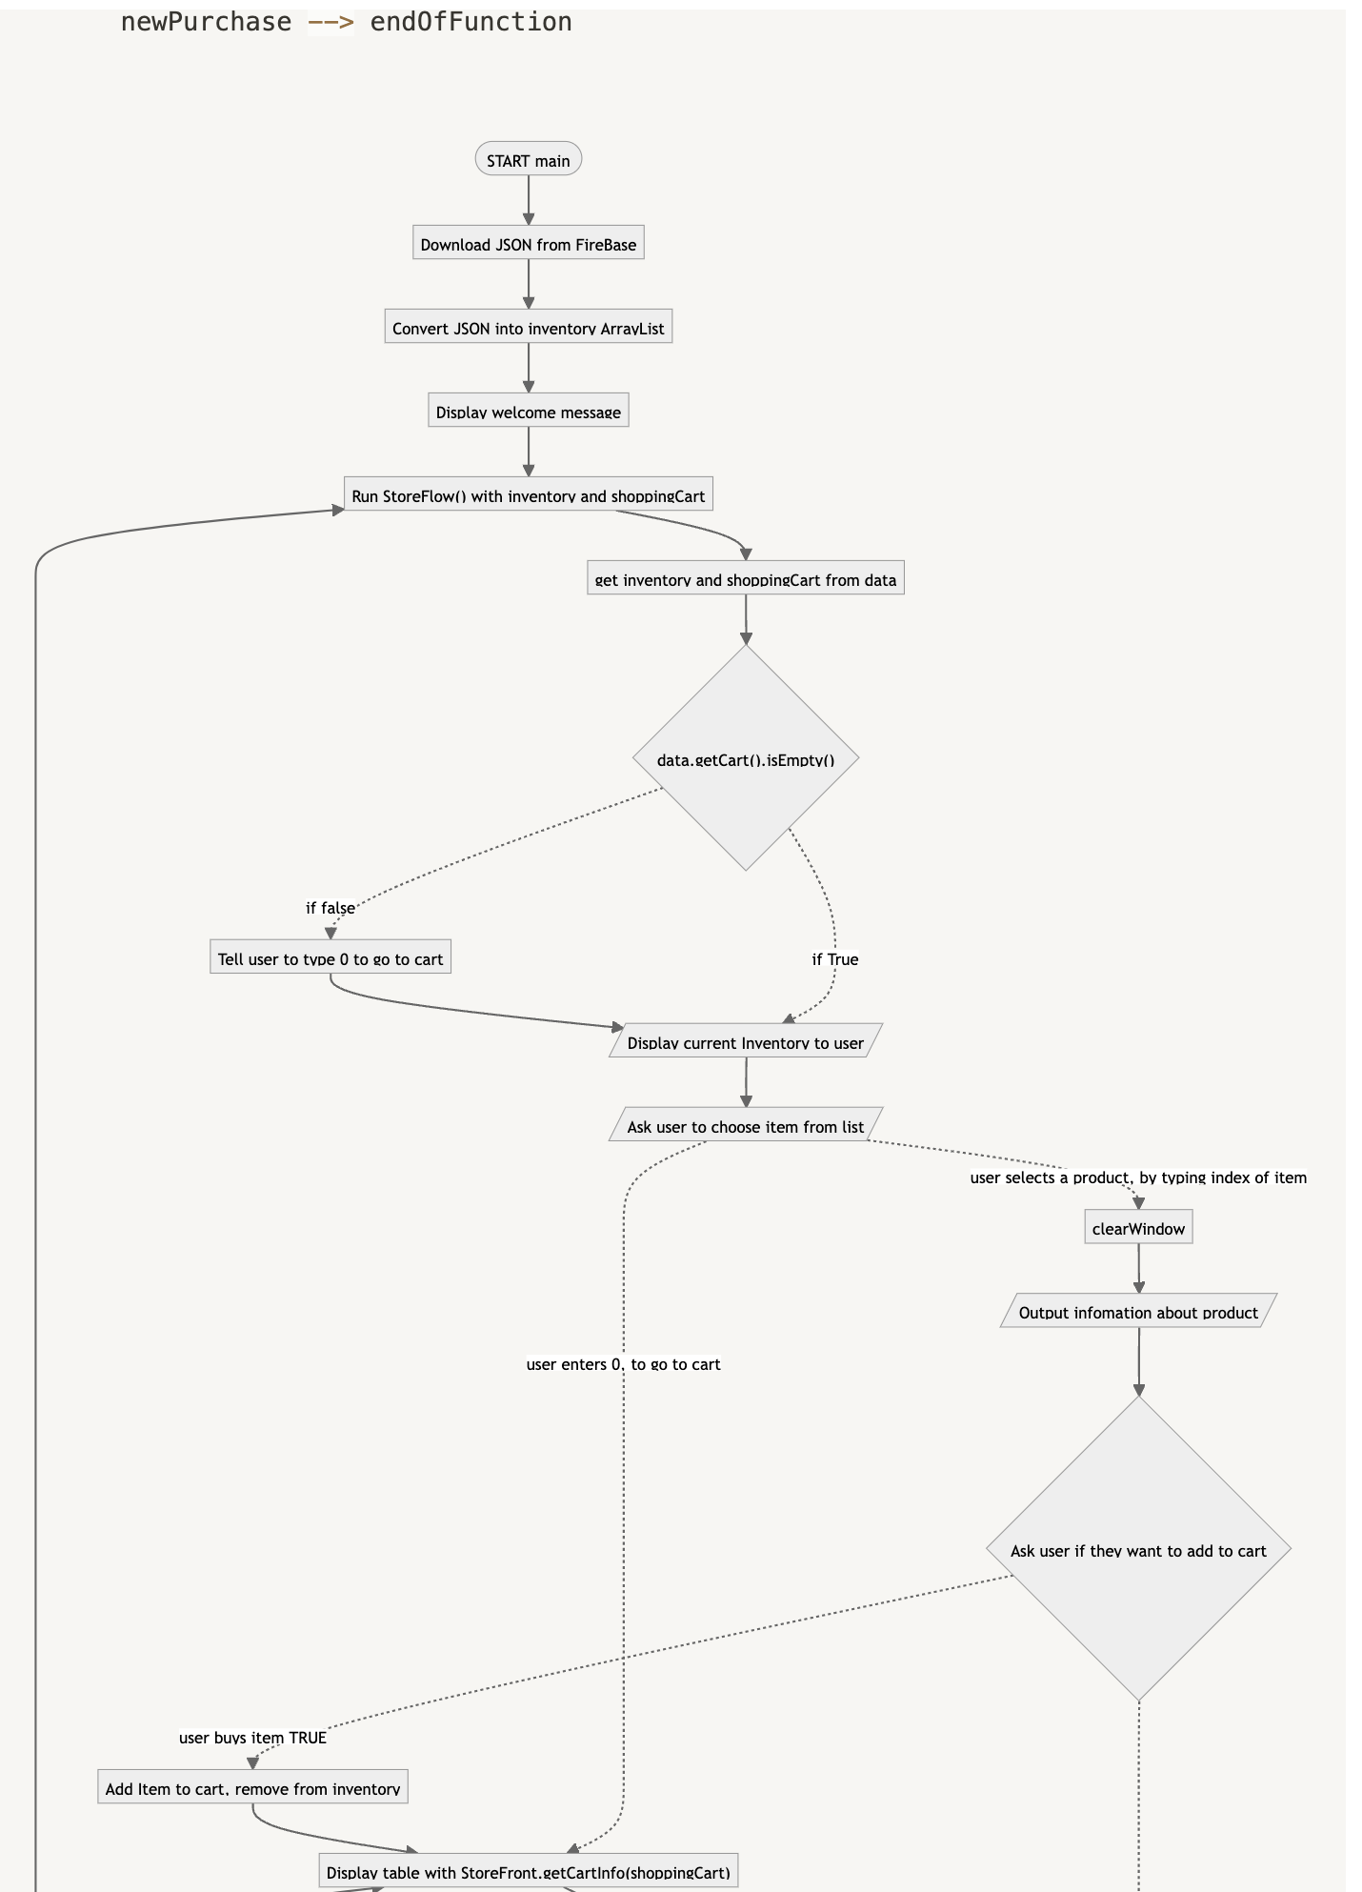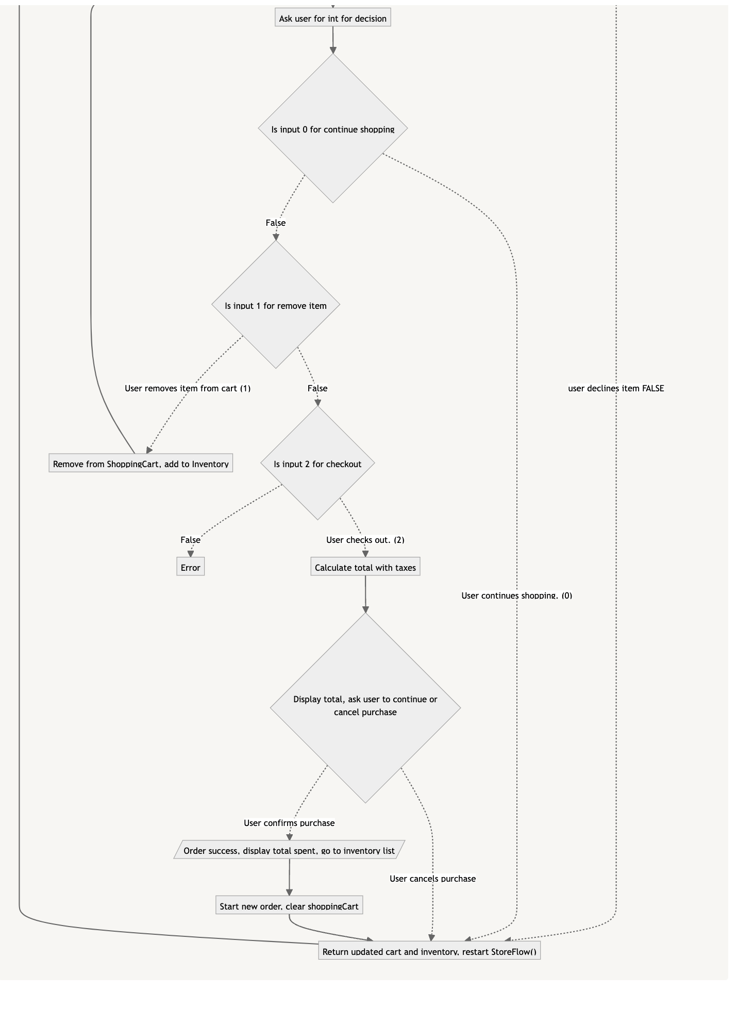

Class Diagram: For an easier to read version of this please use the notion link above. 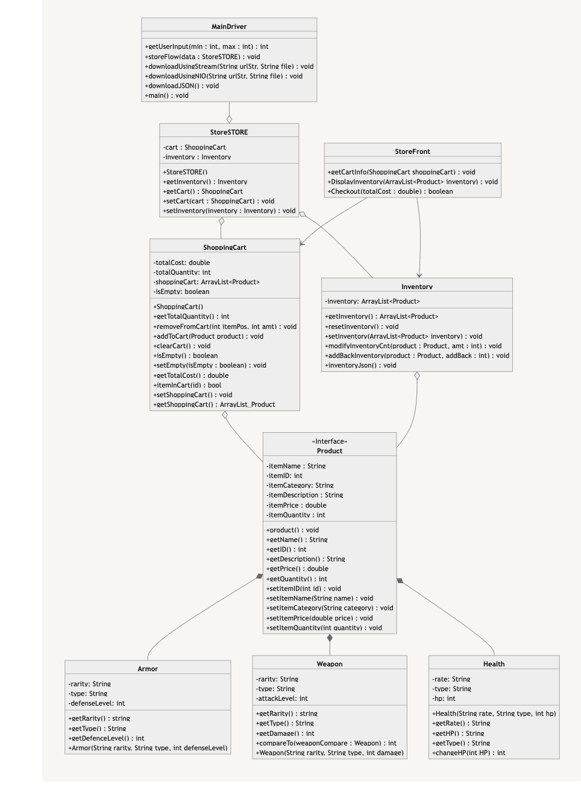

**References**

FasterXML. “jackson” b4add1c, FasterXML, 2023. https://github.com/kandicst/Java-Console-Table.

Kandic, Stefan. “Java Console Table” ed28e7b, kandicst, 2019. https://github.com/kandicst/Java-Console-Table.

Sales-tax.com. (2020, January 1). *Arizona Sales Tax*. Sales Tax Rates. Retrieved February 2, 2023, from https://www.sale-tax.com/Arizona

Pankaj. (2022, August 3). *Java download file from URL*. DigitalOcean. Retrieved March 12, 2023, from https://www.digitalocean.com/community/tutorials/java-download-file-url